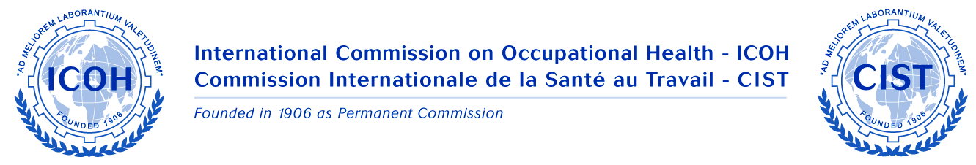
Minutes of the Regional Meeting og ICOH National Secretaries, Casablanca, 29 October 2010

Date: 29 October 2010
Place: Medicine Faculty of Casablanca, Casablanca, Morocco

Participants:
Abdeljalil El Kholti, National Secretary for Morocco
Babacar Fall, National Secretary for Senegal
Rafik Gharbi, National Secretary for Tunisia
Jose Carneiro, National Secretary for Brazil
Louis Patry, National Secretary for Canada
Kazutaka Kogi, ICOH President
Ruddy Facci, Former ICOH Vice President
Edoardo Santino, Former National Secretary for Brazil

- Welcome
Kazutaka Kogi, ICOH President, opened the meeting and welcomed the participants. The meeting was held on the occasion of the Eighth International Conference on Occupational health for Health Care Workers. Prof. El Kholti assisted ICOH in organizing this meeting. Then each participant introduced himself.

- Activities of ICOH
Kazutaka Kogi reported on 2009-2012 ICOH activities along the action plans for promoting proactive risk management and extending occupational health services for all workers, with an emphasis on the roles of National Secretaries. Recent progress in membership campaign, information activities, research through Scientific Committees and cooperation with international allies was mentioned.

- Activities of the National Secretaries
Each National Secretary presented the current ICOH activities in the country.
- Babacar Fall, National Secretary for Senegal, reported a special membership campaign for young professionals and training activities on occupational diseases.
- Abdeljalil El Kholti, National Secretary for Morocco, made a special effort for recruiting new ICOH members. The on-going Conference of the Scientific Committee on Occupational health for Health Care Workers gave an important impetus for the campaign.
- Louis Patry, National Secretary for Canada, reported similar experiences in Canada. The need for assisting new members for paying membership fees was mentioned.
- Rafik Gharbi, National Secretary for Tunisia, mentioned the cooperation with the National Association. The importance of providing support for attending ICOH meetings and emphasizing the benefits of joining ICOH was stressed.
- Jose Carneiro, National Secretary for Brazil, reported the recent progress in membership campaign and emphasized the merits of cooperating with national and regional associations and using websites.
In the discussion, the need was emphasized to strengthen the membership campaign and to coordinate the payment of membership fees in respective countries in view of the difficulties in transferring foreign currencies.

- Regional cooperation
The participants agreed with the importance of closely cooperating with national and regional associations. Louis Patry and Ruddy Facci stressed the need to increase the visibility of ICOH through national and regional conferences. The use of promotional leaflets and webpages for this purpose was suggested. The participants also agreed to collaborate for promoting the ICOH 2012 Congress in Mexico and the activities of Scientific Committees and Working Groups in the region.

- Closing
Closing comments were made by Kazutaka Kogi with thanks to the continued collaboration of the National Secretaries in the region.

